Owner’s Name:_______________________________________ Cell:________________________

Address: _______________________________________City:_______________State:_________Zip:_________

Email _________________________________________________________________

Payment: Check Cash PayPal/Venmo

Horse Information: Negative Coggins Required (attached) EIA #:__________________ Date Tested: ____________
C

Register name:_______________________________ Aka:___________________Gender:________ Age:__________
Event:_________________________________ Color:____________________

Services requesting: Conditioning or Rehabilitation (please check all services you want and how many times)
C
C

Swimming - _____ AquaPacer _____ Cross-training ______ Live Blood Review Detox Therapy
C
SPA _______ Theraplate _____ Laser or PEMF ____ Equi Resp ____ Fecal Count Other

What does your horse currently eat? (type and amount)
AM/PM:_____________________________________________ HAY: COASTAL/ALFALFA (I UNDERSTAND THERE IS AN EXTRA CHARGE FOR ALFAFA ($3.00 PER FLAKE OR $40 PER BALE)
Supplements: _______________________________________We do offer OE and Young Living Products

Does your horse have any injuries, or other medical problems (history of surgery, colic)? YES NO
If yes, please explain: __________________________________________________________

Does horse have any history of behavioral issues? YES NO
(biting, kicking, rearing, pulling back when tied, Cribbing, weave) If yes, please explain: __________________

Is the horse Vaccinated? Yes NO

Has this horse ever had or been exposed to Equine Infectious Anemia, Strangles, Equine Herpes, or any other contagious equine disease OR Fever within the last 14 days? YES NO (if yes – When:____________)

  - Veterinarian Name: ____________________________Clinic: _______________________________
  - Work phone: (____) ________________________ Cell phone: (____) ____________________

How did you hear about CFE? Circle one Facebook Website Friend or Vet:__________________

Championfit Equine is not an Equine Veterinarian Hospital. We do not intend to diagnose or cure any diseases or lameness issues. We are simply horse savvy personals with the newest and improved equipment to help aid in the fitness and conditioning of your equine athlete. We recommend that you speak to your equine vet and discussed the best rehabilitation and/or fitness options for your horse. For your convenience, we have an Equine Veterinarian available to give a thorough wellness exam to make sure your horse is healthy for the Swimming Pool and AquaPacer Treadmill.
______ Yes, I would like to set up a wellness exam prior to services.
______ No, I have already spoken with my veterinarian and my horse is ready for CFE services.
Waiver
I understand that the services provided are not at the discretion of a veterinary diagnosis, unless the patient has a direct veterinary referral. I also understand there is always risk when operating these services and even greater risks when the animal behavior is not conducive to the activity. I agree that if the threatening animal behavior results in any form of injury to itself that the Championfit Equine, LLC is not responsible. Championfit Equine, LLC has the authority to terminate any service at any point in time for the safety of staff and the animals. I agree that the Championfit Equine, LLC can refuse services at any time to any client if they feel that the animal visibly must undergo a veterinary examination or that authoritative personnel feels it unsafe to the animal. I further understand that I am requesting the services to be provided by Championfit Equine, LLC and that I am fully aware that there are no warranties, either express or implied, or promises of results of any kind or character regarding the services provided by Championfit Equine, LLC or the results of the services by Championfit Equine, LLC. Accordingly, I hereby release, waive, discharge, indemnify, and hold harmless Championfit Equine, LLC, and its employees, from any and all claims, of any kind of character, that I might have now, or in the future, to any claim of injury or damage to the horse named above. I agree to allow staff to dispense all listed medications and supplementations when the animal is boarding overnight., I understand that Championfit Equine, LLC is not responsible for any equestrian activities that result in an accident during arena rental use, or for any equine events or participation while on the premises of Championfit Equine, LLC. CFE has my permission to use photos/videos on all social media. Finally, I understand that payment for services is immediate, late fees are accrued at 3.4 % and horse is not able to be pick-up without payment. If horse is left at CFE over 30 days without payment, I relinquished all rights to the said horse on this form.
Client/Owner Signature: ____________________________________________________ Date: ______________________
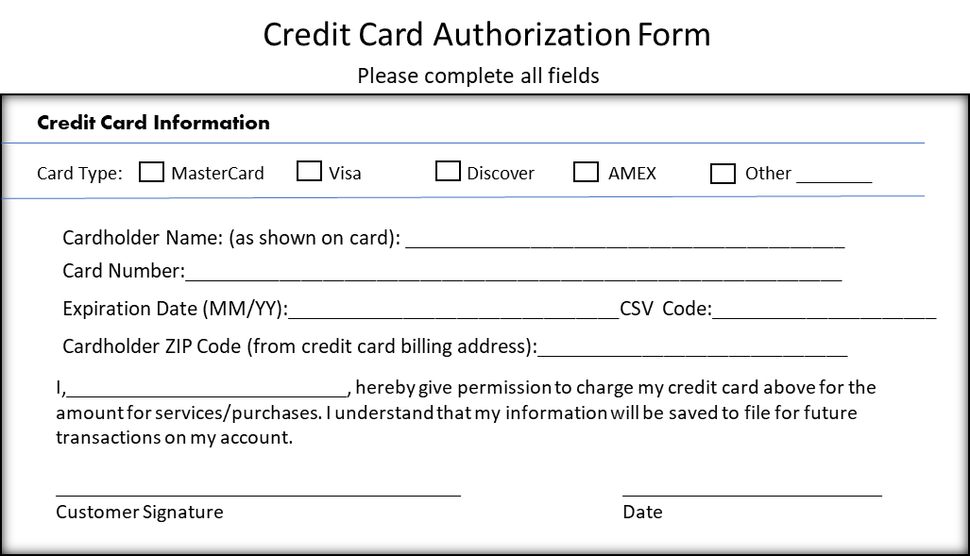
OFFICE USES:

Check In Date:___________________
Horse:______________________________________
Comments:___________________________________________________________________________________________________________________________________________________________________________________
WEIGHT (in) _______________ (out)_______________
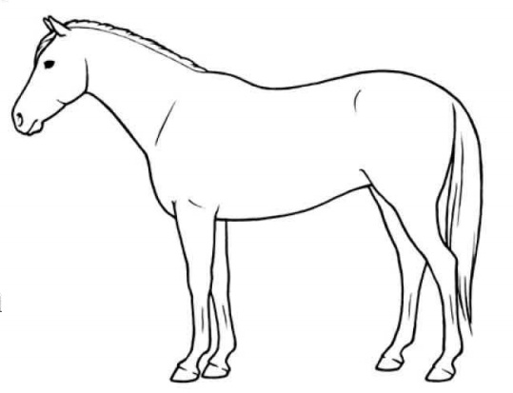
Right side
Left side

